 | Sinhgad Technical Education Society’s  SMT.KASHIBAI NAVALE COLLEGE OF ENGINEERING, PUNE-41 Department of Computer Engineering
Question bank
Sub: DELD
UNIT -I: Boolean Algebra and Simplification Techniques
1) Prove the De Morgan’s theorem with truth table
2) Simplify the following Boolean function F(A,B,C,D)=∑m(0,2,4,5,6,7,8,10,13,15) using K-Map.
3) Convert POS expression into canonical POS form
1) (A+B)(B'+C) 2) (A+B) (B'+C') (A'+B)
4) Convert following equations into canonical Form
i)Y=AB+ACD ii) (A+B) (B’+C)
5) Prove following Boolean algebra theorems using truth table
i) AB+A’C=(A+C)(A’+B) ii) (A+B)(A’+C)(B+C)= (A+B)(A’+C)
6) Minimize following functions using K-map F(A,B,C,D) = Σ m(1,5,7,13,15)+Σ d (0,6,12,14) 7) Minimize following functions using K-map F(A,B,C,D) = πM (4,5,6,7,8,12) . d (1,2,3,9,11,14) 8) Represent the following decimal numbers in
i) Sign Magnitude form ii) 1’s Complement form iii) 2’s Complement form 1) +14 2) +28 3) -52 4)-52 5) -22 6) +28
UNIT II: Combinational Logic Design
1) How will you implement full adder using two half adder? Explain with circuit diagram.
2) Design and explain half adder and full adder circuit using k-map
3) Design and explain half Subtractor and full Subtractor circuit using k-map 4) How we implement full subtractor using two half subtractor.
5) Explain the rules for BCD addition with suitable example and design one digit / 4 bit BCD adder using IC 7483.
6) Explain look ahead carry generator with suitable diagram.
7) Design & explain 4 bit parallel adder with circuit diagram.
8) Design a BCD to excess -3 code converter using logic gates.
9) Design 4-bit binary to gray code converter and implement using logic gates.
10) Design 4-bit gray to binary code converter and implement using logic gates.
11) Design 2-bit comparator using K-map and implement it.
Prepared By Dr. S. P. Pingat

 Study material provided by:Vishwajeet Londhe

 Telegram Channel
(for all engineering Resources)
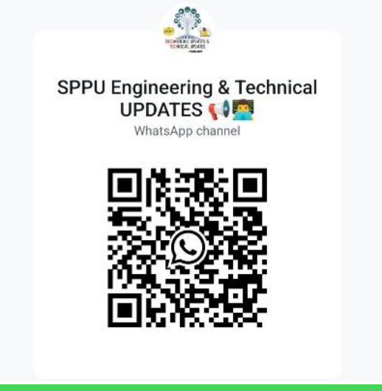 | 
https://whatsapp.com/channel/ 0029ValjFriICVfpcV9HFc3b



Sinhgad Technical Education Society’s
SMT.KASHIBAI NAVALE COLLEGE OF ENGINEERING, PUNE-41 Department of Computer Engineering
12) Design the following function using single 4:1 MUX and logic gates.
F(A,B,C,D)= ∑m(0,1,5,9,10,15)
13) What is MUX? Draw and explain 4:1 and 8:1 multiplexer. 14) Compare the multiplexer and demultiplexer.
15) What is DEMUX? Draw and explain 1:4 and 1:8 demultiplexer.
UNIT III: Sequential Circuits
1.Write short note on one-bit memory cell.
2.Draw and explain SR flip-flop using NAND gates.
3.Draw and explain the diagram of JK flip-flop using NAND gates and explain how race around condition is avoided?
4.Explain Race around condition and also state the remedial action for it.
5.Explain operation of a master-slave JK flip-flop.
6.What is the use of PRESET and CLEAR terminals in filp-flop? Write a short note on JK master slave filp-flop.
7.Convert: (i) JK FF to SR FF (ii) T FF to SR FF.
8.Convert D to T flip-flop and vice versa
9.Explain how JK F/F is converted to T F/F?
10.Convert: i) SR F/F to T F/F ii) D FF to JK FF
11.Perform the following conversion: (i) JK FF to D FF (ii) SR FF to JK FF.
12.Draw circuit diagram and explain 4-bit Universal shift register.
13.Explain registers in details: SISO, SIPO, PISO, PIPO, Shift Registers 14.Explain counters in details: Ring Counter, BCD Counter, Johnson Counter
Prepared By Dr. S. P. Pingat

Sinhgad Technical Education Society’s
SMT.KASHIBAI NAVALE COLLEGE OF ENGINEERING, PUNE-41 Department of Computer Engineering
UNIT-IV: Algorithmic State Machines and Logic Families
1.What is FSM? State advantages and disadvantages of finite state machine?
2.Explain terms related to ASM chart: i) State box ii) Decision box iii) conditional box.
3.Give and construction of ASM chart with example
4.Explain with example ASM chart and realization for sequential circuits.
5.What is Logic family? Give the classification of logic families and also state and explain any four characteristics of digital ICs.
6.Explain Classification of logic families: Unipolar and Bipolar Logic Families.
7.Explain all Characteristics of Digital ICs.
8.Describe the characteristics of CMOS family and explain the operation of CMOS Nor gate. 9.Explain in short Introduction to TTL & CMOS.
10.Compare TTL and CMOS logic families with datasheet parameters.
Unit V - Programmable Logic Devices
1.Explain PLDS: PLD and ROM as PLD
2.Explain in detail Programmable Logic Array (PLA): Implementation procedure, Construction and working.
3.Give PLA’s Advantages over read only memory and applications.
4.Explain Programmable Array Logic (PAL): Architecture and Programming of PAL’s 5.Give construction and working of PAL.
6.Explain designing of combinational circuits using PLDs.
Prepared By Dr. S. P. Pingat

